Project Design Phase
Problem – Solution Fit Template
Date | 19 February 2026
Team ID | LTVIP2026TMIDS35300
Project Name | Civil Engineering Insight Studio
Maximum Marks | 2 Marks

Customer Segment
Segment | Description
Civil Engineers | Professionals who need structural analysis and documentation from construction images
Construction Supervisors | Site managers who need quick material identification and progress documentation
Project Managers | Professionals who monitor project progress and require structured reports
Civil Engineering Students | Learners who want to understand structural components and materials from real-world images

Customer Problems
Core Problems (User Side)
Problem ID | Problem Description | Type
P1 | Manual structural analysis from images is time-consuming | Frequent
P2 | Difficulty identifying materials and structural components accurately | Critical
P3 | Preparing detailed structural reports requires high expertise | Challenging
P4 | Project progress documentation from images is slow | Inefficient
P5 | Lack of automated tools for structural image analysis | Limiting

Existing Behavior (Current Situation)
Civil Engineer / Supervisor
↓
Takes construction site images
↓
Manually inspects structural components
↓
Prepares reports manually
↓
Spends significant time documenting details
Users currently:
- Inspect images manually
- Identify materials based on experience
- Prepare reports using manual documentation
- Cross-check details repeatedly
- Spend hours analyzing structural elements

Emotional Impact
Problem | User Feeling
Manual analysis | Overloaded
Time-consuming reporting | Frustrated
Complex structural interpretation | Pressured
Risk of missing details | Concerned
No automation | Inefficient

Proposed Solution (Civil Engineering Insight Studio)
Core Solution
An AI-powered web application that:
- Allows users to upload construction images
- Analyzes structures using Gemini Pro Vision model
- Automatically generates structured structural descriptions
- Identifies materials and structural components
- Provides project progress insights

Solution Features Mapping
Problem | Solution Feature | Fit Explanation
Manual analysis | AI-based image analysis | Reduces human effort
Time-consuming reporting | Auto-generated structured report | Saves time
Material identification difficulty | AI material detection | Improves accuracy
Project documentation delays | Instant structural insights | Faster reporting
No automation | Generative AI integration | Modern intelligent solution

Functional Fit
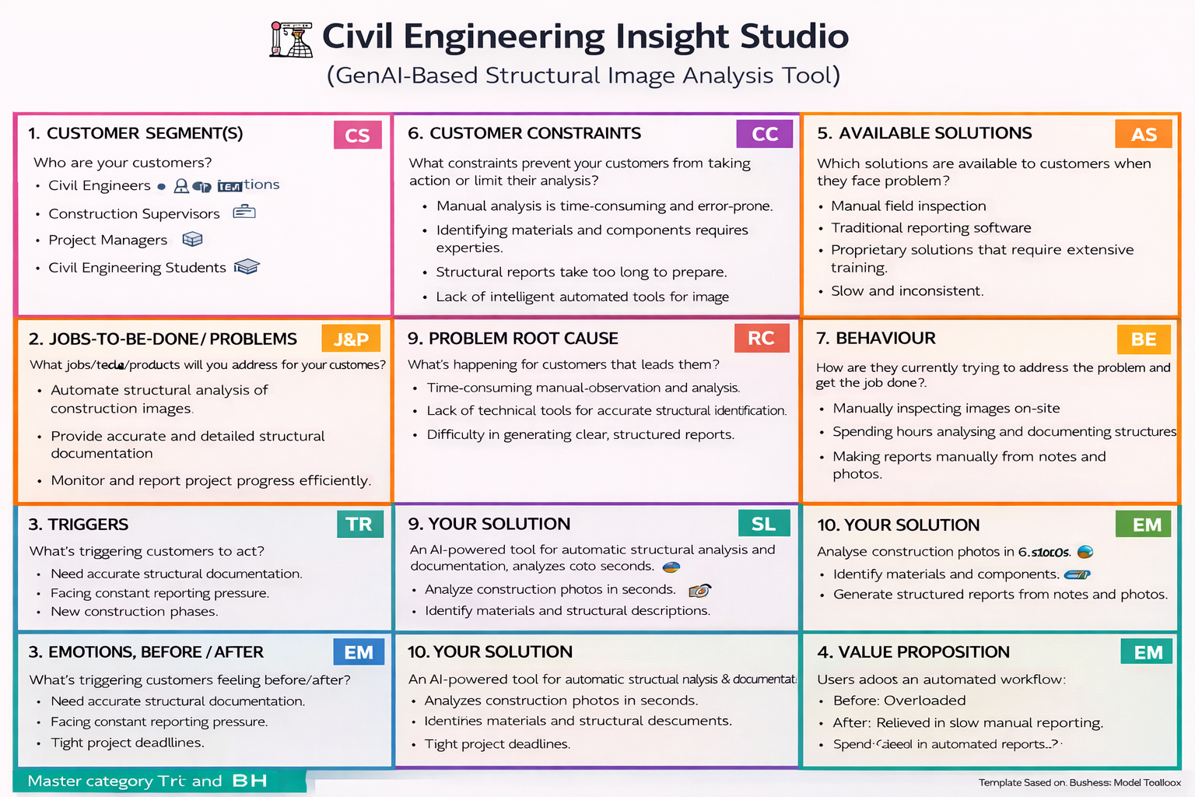
Instead of:
- Manually inspecting images
- Writing reports from scratch
- Spending hours analyzing components
Users now:
- Upload image
- Enter prompt
- Get AI-generated structural report instantly
This aligns with modern AI-driven digital workflow.

Behavioral Fit
Users adopt an automated workflow:
- Image upload
- AI-based processing
- Instant structural documentation
This supports faster decision-making and efficient project communication.

Value Proposition
For Civil Engineers | For Supervisors | For Project Managers
Faster structural analysis | Quick material identification | Improved project tracking
Accurate documentation | Reduced manual workload | Better reporting efficiency
Reliable AI insights | Time-saving automation | Improved decision-making

